PHARMACY MANAGEMENT SYSTEM



**DATABASE SYSTEM**

**AUTHOR:**

SUDAIS KHAN

* FA20-BSE-042

**SECTION: BSE-3B**

**Semester: 3rd**

**Submitted to Mr Tahir Ahmed**

**QUERY OF PHARMACY MANAGEMENT SYSTEM:**

**create** **Database** PharmacyManagementSystem;

**use** PharmacyManagementSystem;

**Create** **table** **pharmacy**(

pharmacy_id **int** **primary** **key** **not** **null** **auto_increment** **primary** **key**,

pharmacy_name **varchar**(**50**),

pharmacy_type **varchar**(**50**),

pharmacy_address **varchar**(**50**)

);

**Insert** **into** **pharmacy**(pharmacy_name,pharmacy_type,pharmacy_address)

**values**('Booali Sina','CMH Pharmacy','Attock City'),

('RMI','hospital Pharmacy','Peshawar'),

('AL-Noor','hospital Pharmacy','Swabi'),

('Aslam_Marwat','hospital Pharmacy','Charsadda'),

('Shiffa','MH Pharmacy','Wah Cantt')

**Create** **table** **Medicines**(

medicine_id **int** **primary** **key** **not** **null** **auto_increment** **primary** **key**,

medicine_name **varchar**(**50**),

medicine_company **varchar**(**50**),

medicine_cost **int**,

medicine_type **varchar**(**255**),

medicine_dose **int**,

medicine_description **varchar**(**255**)

);

**insert** **into** **medicines**(medicine_name,medicine_company,medicine_cost,medicine_type,medicine_dose,medicine_description)

**values**('Panadol','Getz Pharma',**50**,'Tablet',**450**,'This Medicine is use For Fever and Headache'),

('Extor','Gsk Pharma',**400**,'Tablet',**1000**,'This Medicine is use For Blood Pressure'),

('Augmentine','Peek Pharma',**500**,'Syrup',**300**,'This Medicine is use For Coughing'),

('Zental','Black Pharma',**20**,'tablet',**150**,'This Medicine is use for removing worm'),

('Omega','White Pharma',**80**,'Tablet',**250**,'This Medicine is use for Vitamans')

**create** **table** **stocks**(

Stock_id **int** **primary** **key** **not** **null** **auto_increment** **primary** **key**,

Stock_items **varchar**(**50**),

Stock_number **int**,

Stock_type **varchar**(**50**),

Stock_description **varchar**(**100**)

);

**insert** **into** **stocks**(Stock_items,Stock_number,Stock_type,Stock_description)

**values**('Injection',**21**,'Infusion','Its use for Fever and other disease'),

('Syrup',**40**,'Liquid','Its use for fever and High Blood pressure'),

('Insulin',**60**,'Liquid','Its use for Diabetes'),

('Tablets',**79**,'Capsules','Its use for a related diseases')

**Create** **table** **Company**(

Company_id **int** **primary** **key** **not** **null** **auto_increment** **primary** **key**,

company_name **varchar**(**50**),

company_type **varchar**(**50**),

Company_address **varchar**(**50**)

);

**insert** **into** **company**(company_name,company_type,company_address)

**values**('GetZ Pharma','International','Attock City'),

('Shifa Pharma','Local','Islamabad'),

('AL-Ahmad','Local','Swabi'),

('RMI','International','Peshawar'),

('ABS','Domestic','Abbotabad')

**QUERY:**

**Select** * **from** Company

**order** **by** company_name

**Select**\***from** company

**order** **by** company_name **asc**

**Select**\***from** company

**order** **by** company_name **desc**'

**select**\***from** company

**where** company_name='GetZ Pharma' **or** Company_address='Attock City'

**update** company

**Set** company_name='AGS'

**where** company_id=**5**

**Select**\***from** company

**where** **Not** Company_address='Attock City'

**select**\***from** company

**where** company_id **between** **2** **and** **4**

**select**\***from** company

**where** company_name **Like** '%I'

**Select**\***from** company

**where** company_name **Like** '__I%'

**Select**\***from** company

**where** company_name **Like** 'A%'

**Query Explanation:**

* **Order By Company_name is use to sort the company name.**
* **And Also Use for Asscending and Descending order.**
* **WHERE Query is use for to find the company name and address.**
* **NOT Query is use for to not in the attribute.**
* **Between Query is use to find Company_id between 2 to 4.**
* **LIKE ‘A%’ Query is use to find the Company_name from First Letter.**
* **LIKE ‘%A’ Query is use to find the Company_name from Last Letter.**
* **LIKE ‘__T%’ Query is use to find the Company_name from the mean position.**
* **UPDATE Query is use to Set the name of Company where id = 1.**

**Pharmacy Attribute Screenshot**

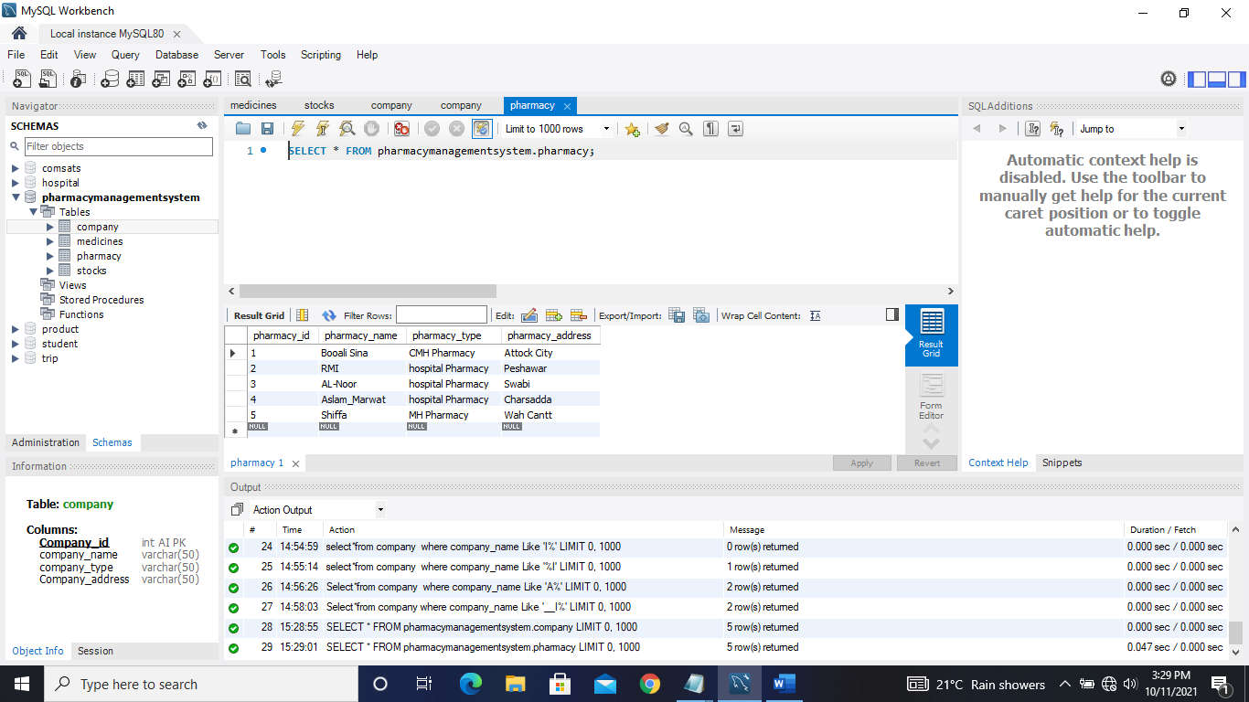

**Medicine Attribute Screenshot**

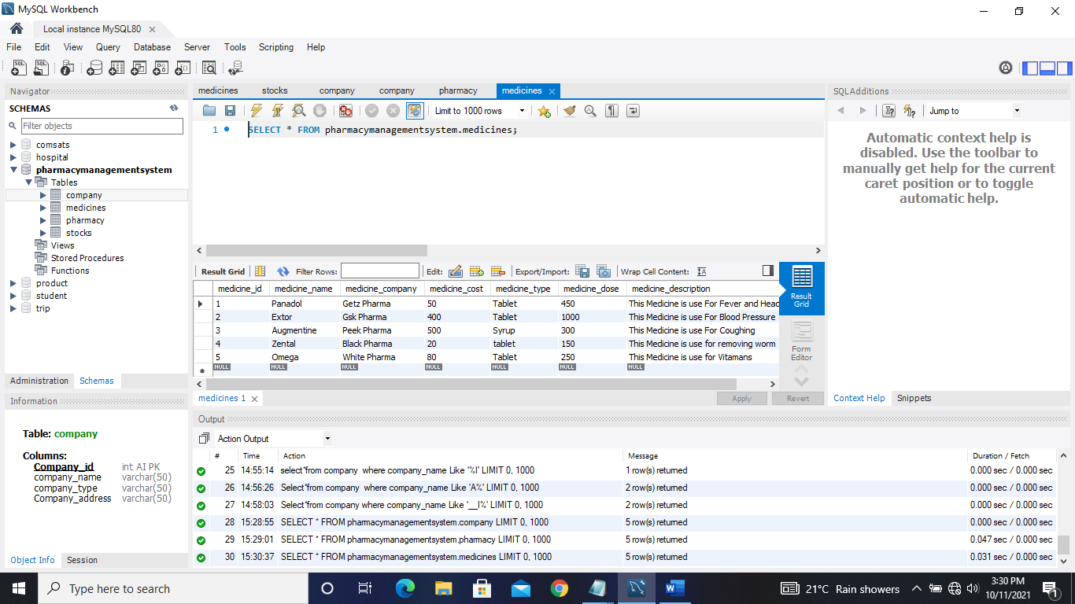

**Stocks Attribute Screenshot**

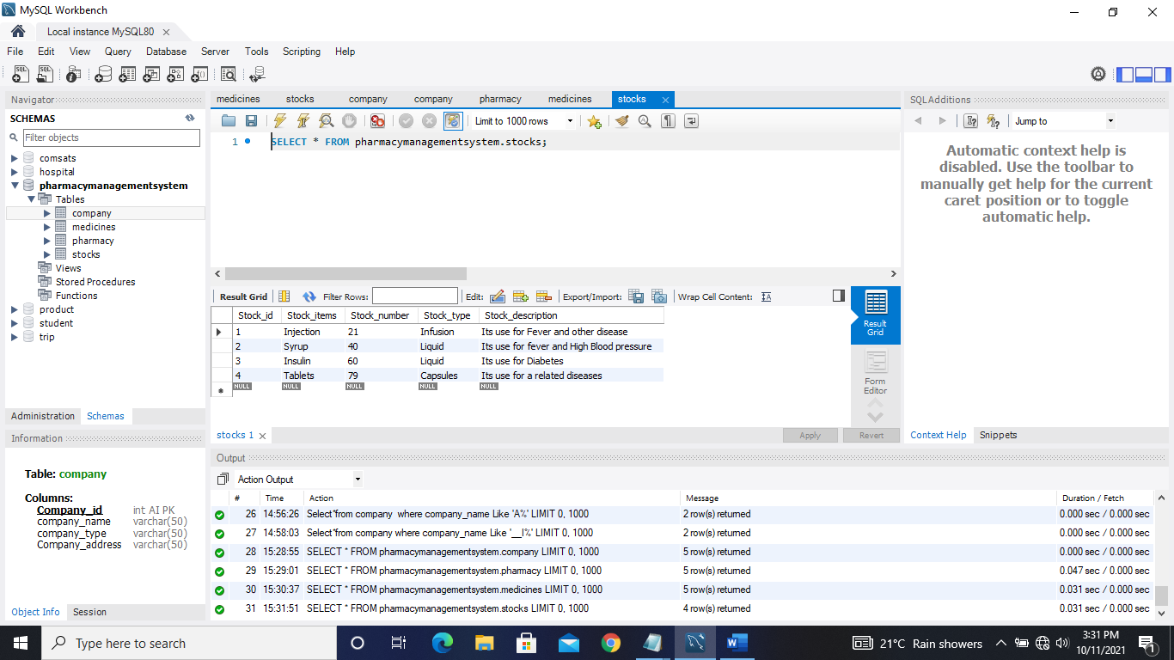

**Company Attribute Screenshot**

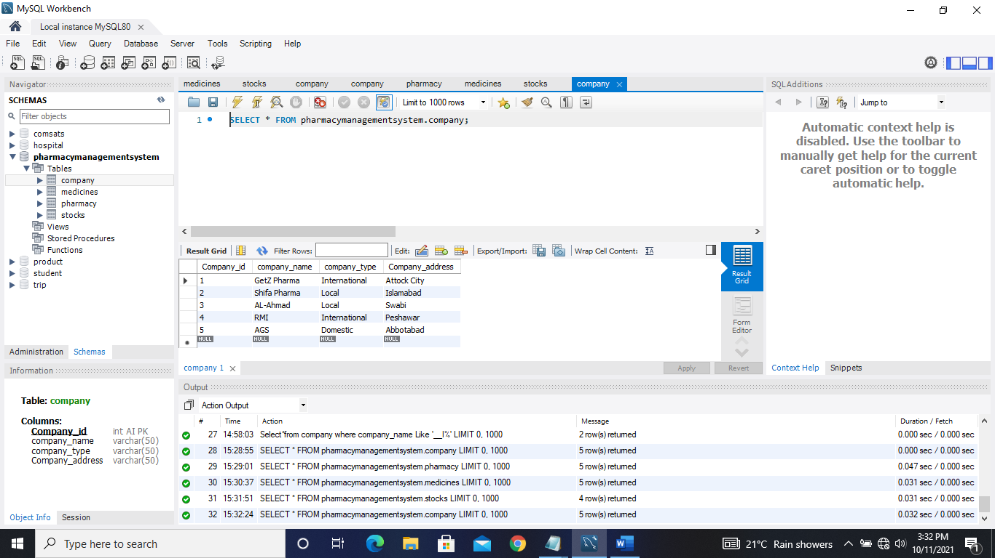

**LAB ASSIGNMENT 2**

**QUERY REPRESENTATION:**

**LIMIT QUERY:**

**Select**\* **from** medicines

**Limit** **3**;

**This query will give the limit to the table columns and in my project Pharmacy Management System where if I give the limit to the table medicines this will only show the 3 rows of every column.**

**LIKE QUERY:**

**Select** medicine_name

**from** medicine

**Where** medicine_name **Like** "ZE%";

**This query will show the column and whose row start from First ZE.**

**And in my project Pharmacy Management System this will only shows these names in medicines table which start from ZE.**

**Select** medicine_name

**from** medicines

**Where** medicine_name **Like** "%EX%";

**This query will only shows the row where EX is available.**

**And in my project Pharmacy Management System I will only shows these medicine_name which there is EX is available.**

**Select** medicine_name

**from** medicines

**Where** medicine_name **Like** "%__tal";

**This query will only show the name or any other column in table where name ends with tal. And in my project Pharmacy Management System it will only show these medicines names which ends with tal.**

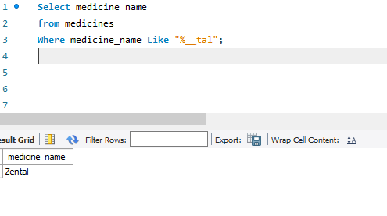

**IN QUERY:**

**Select** *

**from** pharmacy

**where** pharmacy_address **In**("Peshawar","Swabi");

**This query will show the column where Peshawar and Swabi is already exists.**

**And in my project Pharmacy Management System it will only show these column where Peshawar and Swabi already exists.**

**AS QUERY:**

**select** pharmacy_name **as** pharm_name **from** pharmacy;

**This query will replace the coulmn into another column from table.**

**And in my project Pharmacy Management System It will change the pharmacy_name into pharma_name.**

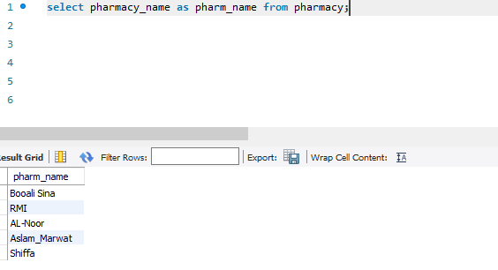

**CONCATINATE QUERY:**

**select** **concat**(pharmacy_name,pharmacy_type )**as** newcoloum

**from** pharmacy

**This query will concatinate the column and another column into newCoulmn**

**In my project Pharmacy Management System I will concatinate the pharmacy_name and pharmacy_type into new Table.**

